Transformation of the generalized chaotic system into canonical form

ARTICLE INFO | ABSTRACT
Article history:  Received  Revised  Accepted | The paper deals with the developing of the numerical algorithms for transformation of generalized chaotic system into canonical form. Such transformation allows us to simplify control algorithm for chaotic system. These algorithms are defined by using Lie derivatives for output variable and solution of nonlinear equations. Usage of proposed algorithm is one of the ways for discovering of new chaotic attractors. These attractors can be obtained by transformation of known chaotic systems into various state spaces. Transformed attractors depend on both parameters of chaotic system and sample time of its discrete model.  Copyright © 2017 International Journal of Advances in Intelligent Informatics.  All rights reserved.
Keywords:
Chaos
Dynamical system
Differential equations
Generalized chaotic system
Nonlinear coordinate transformation

Introduction
The theory of chaotic systems is fast growing branch of the dynamic system’s theory. This branch has a wide application in various spheres of a human activity such as robotic [1], communication [2], cryptography [3], meteorology [4], economy or business application [5], and so on. Great interest to the chaotic systems was caused by their unique properties. The main plus of chaotic systems is the possibility to generate truly random sequences of signals, which can not be obtained in other ways. One can use these sequences in various ways. For example, they can be used for setting up secure data transmission, planning path of mobile robot, investigating of exchange rate fluctuations. This list can be continued for pages.
Wide range applications of chaotic systems have caused a great number of its researches. One can find a lot of papers on researches dynamics and implementations of integer-order [1-3] and fractional-order [6] chaotic systems in continuous-time and discrete-time domains. These researches propose the novel chaotic systems [7] and investigate existing ones [1-3,6].
One of the directions of the chaotic systems’ theory is control of chaotic systems. So many publications on chaos control [7,8] and chaos systems’ synchronization [2,3,9] can be found in scientific press today. The great interest to chaos control is caused by possibility to test novel control algorithms for nonlinear unstable dynamical objects. If these algorithms work correctly for chaotic systems, they will work for various industrial objects with stable dynamics likewise.
The feedback linearization [10] is one of the effective control technique for nonlinear controller construction, but main lack of this linearization is using of object’s complete state vector. This fact make the researcher to set up and to use tons of different sensors. It is obvious that the control system becomes more complex and it is difficult to configure it.
To avoid this lack we propose to transform chaotic system’s dynamic into canonical form. It allows us to use only one sensor in the control system feedback. The transformation of chaotic system into canonical form is known only for one class chaotic systems [11, 12] and it is hard to use it for another one.
In our paper we propose to perform transformation of arbitrary chaotic system into canonical form by using generalized approach based on differential geometry methods and nonlinear algebraic equations’ solution. We suggest using numerical methods while mentioned transformation is being performed. It avoids us to use complex mathematical apparatus and gives numerical algorithms, which can be used as numerical routines while control system is being programmed on microcontroller.
Our paper is organized as follows: firstly we get a transformation procedure for a general dynamical object given in the continuous-time domain. We adapt mentioned procedure for discrete-time domain than. Finally we show usage of proposed approach for transformation continuous-time and discrete-time dynamics of Lorenz system into canonical form.

Method

Continuous-time transformation algorithm for a generalized dynamical object
Let us consider a generalized n-th order continuous-time dynamical object given in the following way
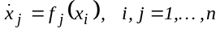, (1)
where 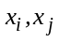 - state variables of dynamical object, 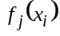 - some nonlinear functions.
We assume that these functions are differentiable in all state variables 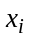 for n times. This assuming allows us to transform (1) into canonical form
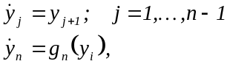, (2)
where 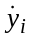 - new state variables, 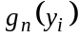 - nonlinear functions.
One can perform above mentioned nonlinear coordinate transformation by using the following algorithm:
- One state variable 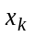 is selected as output variable
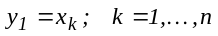, (3)
here k – number of output variable.
- This variable is differentiated for n times and Lie derivatives are defined [10]
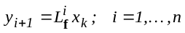, (4)
where is a (nx1)-size matrix of functions
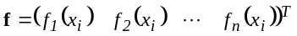. (5)
- The interrelations between new 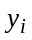 and old state variables are defined as solution the first n-1 equations of (4) for thus
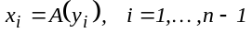, (6)
where 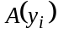 - some nonlinear operator.
- The unknown function is defined from n-th equation of (4) by substituting into the Lie derivative 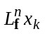 (6).
The given algorithm allows us to get transformed equations of a nonlinear object given by (1) into canonical form. The main lack of proposed method is difficulty in analytically determining of -operator. This operator in the elementary functions can be defined only for the short range right-hand expressions in (1). The determination of -operator is associated with usage of non-elementary functions in general case. The definition of these functions is a separate nontrivial scientific problem with a weak practical usage due to usage of complex mathematical apparatus.
We propose to simplify the determination of -operator by transition into discrete-time domain and using numerical methods.

Discrete-time transformation algorithm for a generalized dynamical object
The known numerical methods are based on various approximations of the differentiation operator. These approximations are built on the basis of future, current, and past values of state variables.
We use a following general approximation of differentiation operator [13]
, (7)
where 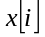 - value of state space variable x in i-th time interval, 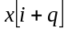 - value of state variable x on q – th time interval in future, 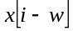 - value of state x on w-th interval in past
or in z-form
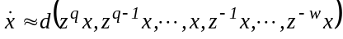, (8)
where 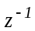 - one step backward shift operator, 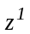 - one step forward shift operator.
An approximation for j-th order differential operator can be written down by using (8) in the following way
(9)
One can rewrite (4) by using (9) thus
. (10)
Solution of (10) allows us to determine interrelations between the new coordinate 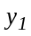 and old one. We propose to use for solution of these equations iterative numerical methods like Newton-Raphson method [14]. This method allows us to write down the following iterative expression for state variables
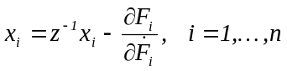, (11)
where
. (10)
Function can be defined by substituting (11) into Lie derivative . This function is used while we are making the transformation of the differential equations (1) into algebraic ones
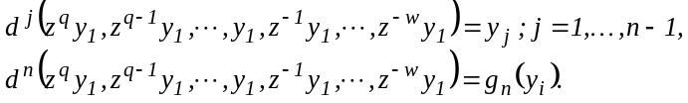 (12)
Numerical solution of (12) allows us to define canonical state variables 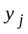 in general case.

Results and Discussion
Now we show two examples of using a proposed approach to transform the differential equations in normal form into canonical one.
We consider a well known Lorenz system, which is given by the following equations [15]
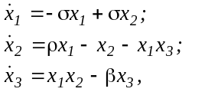 (12)
where 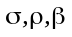 - some coefficients, - state variables.
Equations (12) describe nonlinear object with chaotic dynamic. Let us transform (12) into classical matrix form
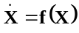, (13)
where
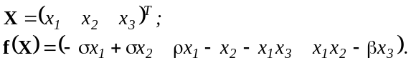 (14)
We consider transformations (12) into canonical form for 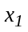 state variables.

Analytical transformation of the Lorenz equations for x₁ variable
After selecting variable as output one we use as new state variables. The new state variables are defined as Lie derivatives of the output variable
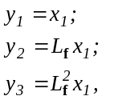 (15)
where
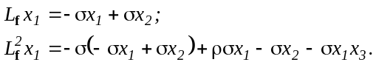 (16)
Let us substitute (16) into (15)
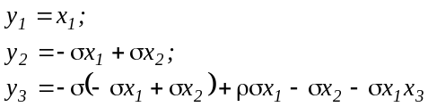 (17)
or
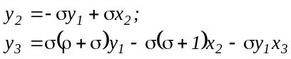. (18)
We solve (18) for the variables 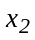 and 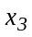
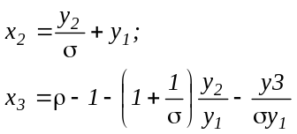. (19)
Now let us find the 3-rd Lie derivative for variables
. (20)
We define an unknown function 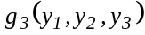 by substituting (19) into (20)
. (21)
Finally, we can write down the Lorenz system’s dynamic in canonical form
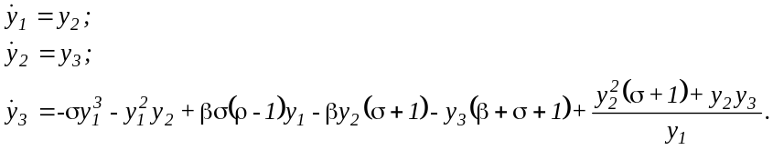 (22)
It is simple to transform 3-rd order system of differential equations (22) into one 3-rd order equation
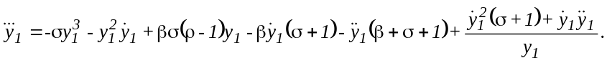 (23)
This equation we call Lorenz equation in canonical form and we call an appropriative dynamical system as continuous-time canonical Lorenz system.
Analyzing (22)-(23) allows us to formulate the following statement:
Statement 1: Equations of nonlinear system’s dynamic in canonical form are more complex than in normal one. Thus, contrary to linear system, which mathematical model is simpler in canonical state space, the transformation of nonlinear system into another state space does not allow us to simplify it.
Numerical solutions of (12) (curve 1) and (22) (curve 2) are shown on fig.1.
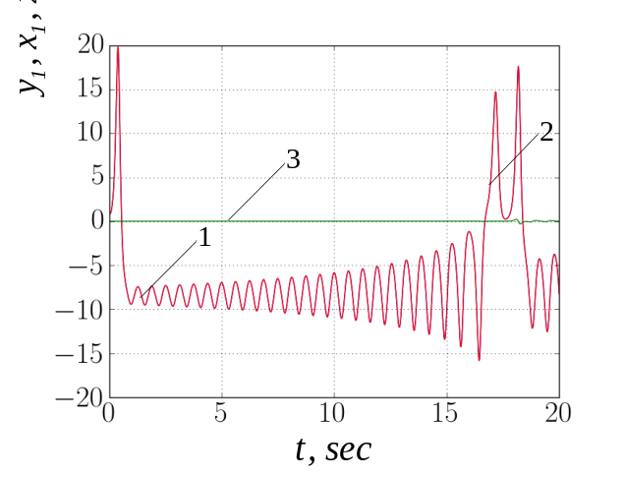
- Results of numerical sollution of (12) and (22) for variable.
The completely coincidence of shown curves is clearly understand. This coincidence is approved by near zero values of error curve 3. Thus, we can claim the correct performing of transformation Lorenz equation into canonical form by using proposed approach.
The usage of proposed approach ensures a coincidence of normal and canonical state spaces by only one variable. That is why other variables are differing. This difference cause different attractors in different state spaces. For example Lorenz attractor in canonical state space and it’s projections are shown on fig.2. It is clearly understand the significant difference between the shown and well-known classical Lorenz attractors.

Numerical transformation of the Lorenz equations for x₁ variable
We define the following functions
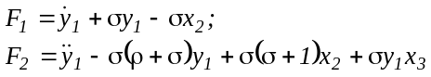. (24)
Let us transform (24) into discrete-time domain by using the simplest backward difference approximation of the differential operator
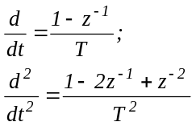, (25)
where T – sample time
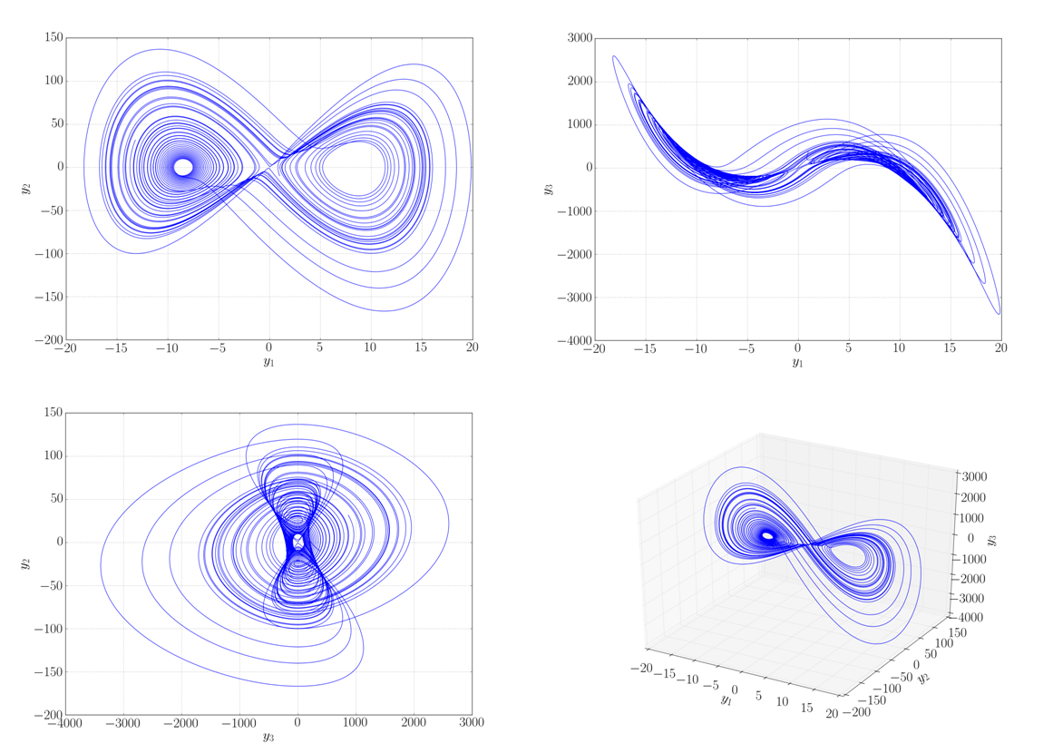
- Lorenz attractor in canonical state space.
as follows
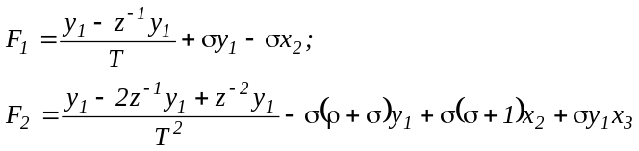 (26)
or
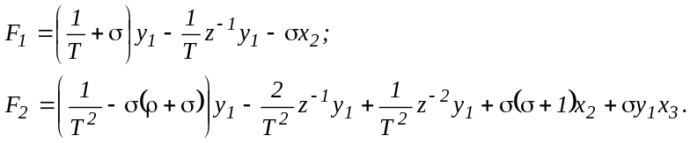 (27)
At first we define variable by using following iterative algorithm based on Newton-Raphson method
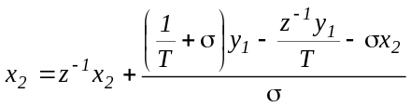. (28)
This algorithm can be simplified as follows
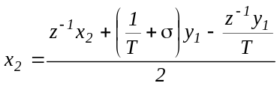. (29)
At last we define variable by using similar to (29) algorithm
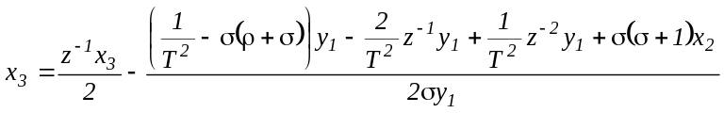. (30)
Equations (29)-(30) allows us to write down the following iterative canonical equations for the Lorenz system given in discrete-time domain
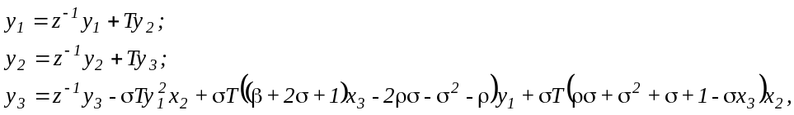 (31)
where
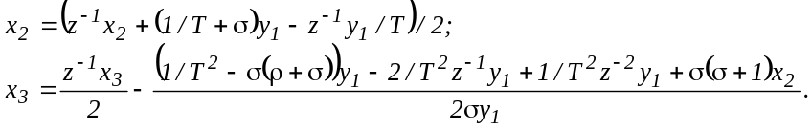 (32)
Equations (31) and (32) are simpler than (22). These equations allow us to define both canonical and normal variables by solving appropriative algebraic equations by using the following algorithm:
- Current values of canonical variables and 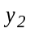 are defined by using first and second expressions of (31).
- Current values of normal variables and are defined by using (32) in iterative way.
- Current value of canonical variable 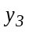 is defined by using third equation (31).
- The cycle is repeated for all simulation time.
Similarly to (23) we call equations (31)-(32) as discrete-time Lorenz equations in canonical form.
It is clearly understand the simplicity of the proposed approach contrary to the solution of differential equations (22). Equations (31)-(32) is depended on sample time T as well as coefficients of equations (12).
So we claim the following statement.
Statement 2. Dynamic of the discrete-time Lorenz system in the canonical form depends not only on it’s parameters but on used numerical method also.
This statement is approved by the numerical solution’s results of (31) and (32) for different sample time (fig.3-4).
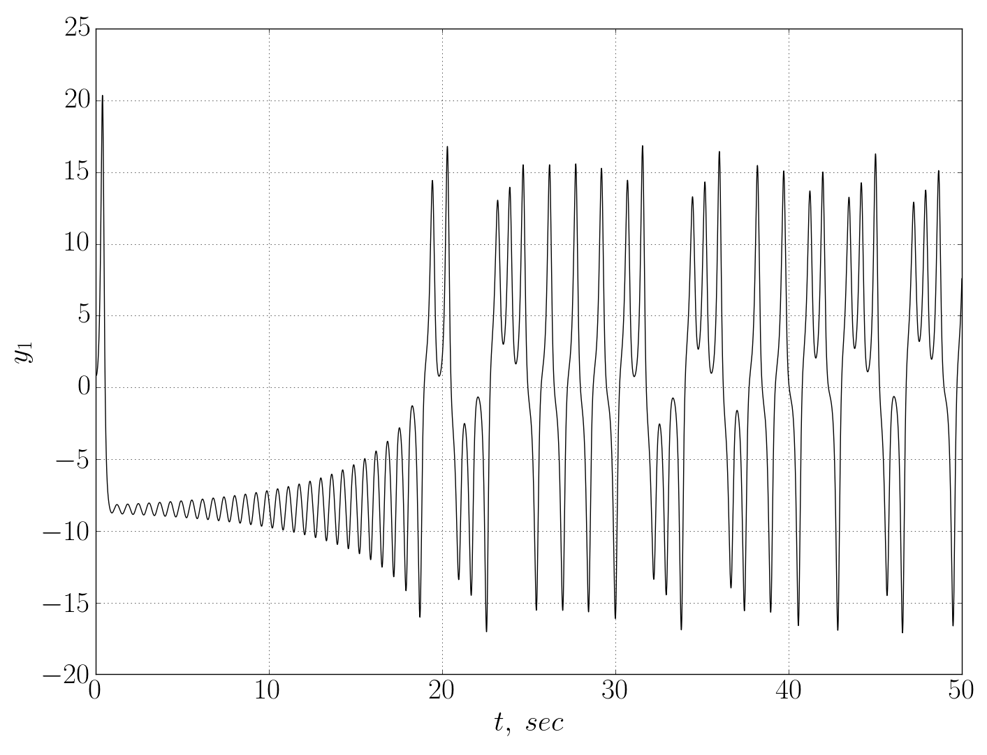
Fig.3 Results of the canonical Lorenz system simulation with sample time 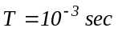
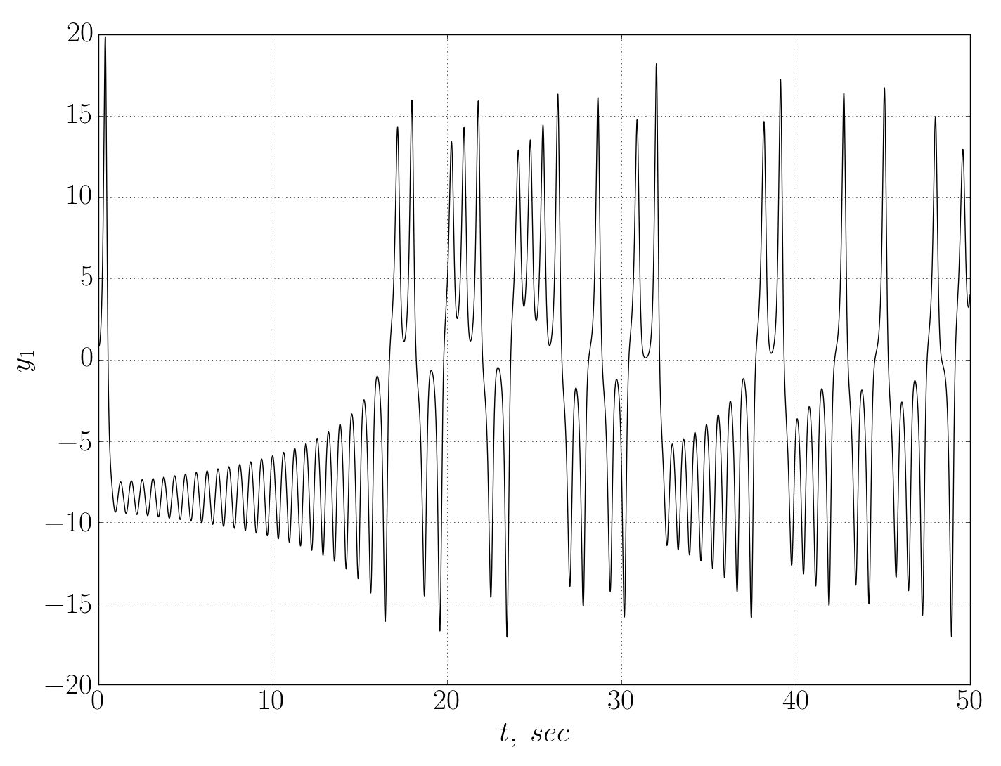
Fig.4 Results of the canonical Lorenz system simulation with sample time 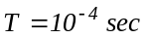
We claim following as result of all given mathematical expressions:
Statement 3: If dynamical system has chaotic attractor in one state space, it has chaotic dynamic in other state spaces.

Conclusion
The dynamic of generalized chaotic system can be transformed into canonical form by defining n-th Lie derivatives and solving n-1 nonlinear algebraic equations. This transformation can be simplified by using numerical methods. One can develop numerical transformation algorithm as a part of controller’s software by using mentioned numerical methods. Usage of proposed algorithm is a one way of new chaotic attractors’ discovering. These attractors can be obtained by transformation of known chaotic systems into various state spaces.

References
- Ch.K.Volos, et al., “A chaotic path planning generator for autonomous mobile robots,” in Robotics and Autonomous Systems, vol. 60, Issue 4, pp. 651-656, April 2012.
- R.Voliansky, A.Sadovoy, “Chua’s circuit synchronization as inverse dynamic’s problem solution,” in Proceedings of 3rd International Scientific-Practical Conference Problems of Infocommunications Science and Technology, pp.171-172, October 2016.
- L.M.Pecora, T.L. Carol, “Synchronization in chaotic systems,” in Phy. Rev. Lett, Vol. 64, No 8, pp.821-824, 1990
- S.Kim, et al. “Identifying and evaluating chaotic behavior in hydro-meteorological processes,”in Advances in Meteorology, Vol 2015, 12p., 2015.
- O.Bajo-Rubio, et al, “Chaotic behaviour in exchange-rate series: First results for the Peseta-U.S.Dollar case,” in Economics Letters, Vol 39, pp.207-211, 1992.
- P.Zhou, et. al., “A fractional-order chaotic system with infinite number of equilibrium points,” in Discrete dynamics in nature and society, Vol. 2013, 6p., 2013
- S.Vaidyanathan, “A novel 3-D jerk chaotic system with three quadratic nonlinearities and its adaptive control,” in Archives of control scieces, Vol.26, pp.19-47,2016
- Ch.Yin, et.al, “Design of sliding mode controller for a class of fractional-order chaotic systems,” in Communications in nonlinear science and numerical simulation, Vol. 17, Issue 1, pp.356-366, January 2012.
- R.Luo, et. al., “Synchronization of uncertain fractional order chaotic system via novel adaptive controller,” in Chinese journal of physics, Vol. 55, Issue 2, pp.342-349, 2017
- A.Isidori, “Nonlinear control system,” Springer-Verlag, London, 549p, 1995.
- S.Celikovsky, G. Chen, “On a generalized Lorenz canonical form of chaotic systems,” in Int. journal of bifurcation and chaos, Vol.12, Issue 8, pp1789-1812, August 2002.
- S.Celikovsky, et. al., “Silnikov chaos in the generalized Lorenz canonical form of dynamical systems,” in Nonlinear dynamics, Vol.39, Issue 4, pp.319-334, March 2005.
- M.Reuter, et.al. “Discrete Laplace-Betrami operators for shape anlysis and segmentation,” in Computer & graphics, Elsevier, Vol.33, Issue 3, pp.381-390, 2009.
- E.Suli, D.Mayers, “An introduction to numerical analysis,” Cambridge university press, New York, 445p, 2003
- A.Pchlintsev, “Numerical and physical modeling of the dynamics of the Lorenz system,” in Numerical analysis and applications, Vol.7, Issue 2, pp.159-167, 2014

